EXPERIMENT – 10
Implementation of Expectation-Maximization (EM) Algorithm using Python
AIM
To implement the Expectation-Maximization (EM) algorithm using Python for estimating the parameters of a probabilistic model from given data.
APPARATUS REQUIRED
- Google Colab
- Python 3.x
ALGORITHM
- Start the program.
- Import the required Python libraries.
- Generate or load the dataset.
- Initialize the parameters of the model.
- Perform the Expectation (E) step to calculate the probability of each data point belonging to each cluster.
- Perform the Maximization (M) step to update the model parameters.
- Repeat the E-step and M-step until the model converges.
- Display the obtained clusters and model results.
- Stop the program.
PROGRAM
# Experiment 10: Expectation-Maximization Algorithm
import numpy as np
import matplotlib.pyplot as plt
from sklearn.mixture import GaussianMixture

# Generate sample data
np.random.seed(42)
X1 = np.random.normal(2, 0.8, (100, 2))
X2 = np.random.normal(7, 0.8, (100, 2))
X = np.vstack((X1, X2))
# Create Gaussian Mixture Model
em_model = GaussianMixture(
n_components=2,
random_state=42
)
# Train the model using EM algorithm
em_model.fit(X)
# Predict cluster labels
labels = em_model.predict(X)
# Display cluster centers
print("Cluster Means:")
print(em_model.means_)
# Plot the clusters
plt.scatter(
X[:, 0],
X[:, 1],
c=labels
)
plt.xlabel("Feature 1")
plt.ylabel("Feature 2")
plt.title("Expectation-Maximization Clustering")
plt.show()
OUTPUT
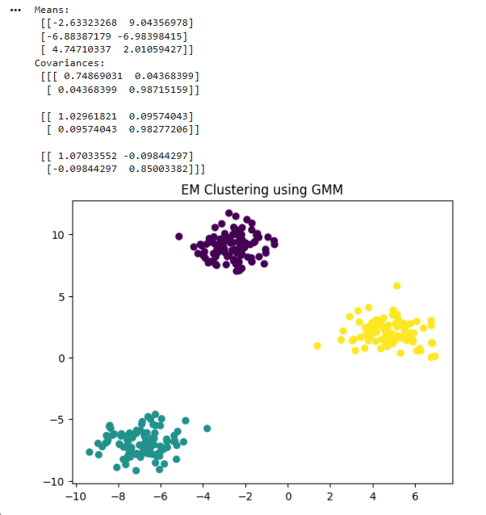
RESULT
Thus, the Expectation-Maximization (EM) algorithm was successfully implemented using Python in Google Colab, and the data points were grouped into clusters.

